**Team 21 - BashGuardians - PartyGuardiOS**

**Client Name: Jacob Stansbury**

**Team member roles & responsibilities**

Spandana - S524987 - Primary Contact  
Pushpak - S525004 - Issues Management  
Vinod - S525117 - Communications and Documentation Management  
Yashwanth - S525056 - Quality and Testing Management  
Nandeesh - S525120 - Requirements Management  
Naveen - S525051 - Data Management  
Sanjeev - S525034 - Client Management

**What our team finished:**

1. **Requirement Discovery**

**Week1:**

* Worked on received prototype for both host/guard user and basic user screens.
* Link for Basic User prototypes: [https://projects.invisionapp.com/share/SB76VFTTR#/screens (Links to an external site.) (Links to an external site.)](https://projects.invisionapp.com/share/SB76VFTTR#/screens)
* Link for Host/Guard User Prototypes: [https://projects.invisionapp.com/share/EN7YELSSH#/screens (Links to an external site.) (Links to an external site.)](https://projects.invisionapp.com/share/EN7YELSSH#/screens)

**Week2:**

* We have grabbed the components required for our project such as Mac Book and iPad from the library.
* We need to acquire some more requirements such as application logo, label constraints and remaining design specifications from the client.

**Week3:**

* We grabbed the designs given by the client to design user interfaces for Situation, Location and Alert screens.
* We need to collaborate with team Invincible techies (Team number: 54) and prepare for the client demo1.

**Week4:**

* We grabbed the designs given by the client to design user interfaces for guard user login screen
* We are preparing Presentation of issue management for this Monday.

**Week5:**

* With the help of the designs given by the client, we have tried to implement the same with functionalities and developing them according to the requirements.
* We have to collaborate with the services team and have to present a demo on the progress since the last demo.

**Week6:**

* Acquired all the requirements necessary for working on Guard user screens
* Need to receive Application logo
* Append the application logo to every developed screen once received

1. **Design Creation/Modification**

**Week1:**

* Completed UI Design for login and signup screens

**Week2:**

* Completed UI Design for App information page and Fraternity list screens

**Week3:**

* Completed integrating three view controllers of basic user & host user login screen, user registration, App information guide screen.
* Completed preparation for the client demo1.

**Week4:**

* Completed creating the guard user interface for the app and tested the screens.
* Started preparation for the client demo2.

**Week5:**

* Completed 50% of the interfaces and started testing them after developing the screens along with coding.
* Preparing for client demo2.

**Week6:**

* Modified the User Interface for some screens as suggested by the client
* Designed separate screens for guard user

1. **Development of Application**

* Done with the user interface of basic user screens completely.
* We started developing guard user screen and host user.
* When guard user logs in a separate screen will appear than the host user without PG team tab.

1. **Client Interaction**

* We are updating the Client Meeting report whenever client meet happens.
* <https://drive.google.com/open?id=1FR9ZvcioBdR7Hpk3j31XQcxXHuUk8ep2aDZeKU9cOBs>
* Noting the changes specified by the client in Minutes of Meeting report.
* <https://drive.google.com/open?id=13KnLNfHwIOEgDZwxFbHwU7ldcGpwbSVuNOHQwdSfxho>

1. **Testing**

**Week1:**

* Didn’t receive iPad and Mac Book.

**Week2:**

* Used iPad for testing the designed user interfaces for login, signup, app information and fraternity list screens.

**Week3:**

* Used iPad for test the user interfaces login, signup, app information and fraternity list screens we designed and the transition between them.

**Week4:**

* Used iPad for test the user interfaces for the appropriate values for the fields like accepting only numbers for phone number and allowing only people above the age of 21 to register.

**Week5:**

* Used iPad for testing the UI developed and also all the validations to be performed on all the fields.

**Week6:**

* Used iPad for testing the modified Guard user and Host user screens.
* Tested the Forgot Password Button whether a message is sent to email for resetting it or not.

1. **Documentation**

* We are updating Client Meeting Report on a weekly basis.
* Link: <https://drive.google.com/open?id=1FR9ZvcioBdR7Hpk3j31XQcxXHuUk8ep2aDZeKU9cOBs>
* Minutes of meeting document is updated after each client meet.
* Link: <https://drive.google.com/open?id=13KnLNfHwIOEgDZwxFbHwU7ldcGpwbSVuNOHQwdSfxho>

**Screenshots of major artifacts for accomplishments:**

1. **Guard User Login screen**

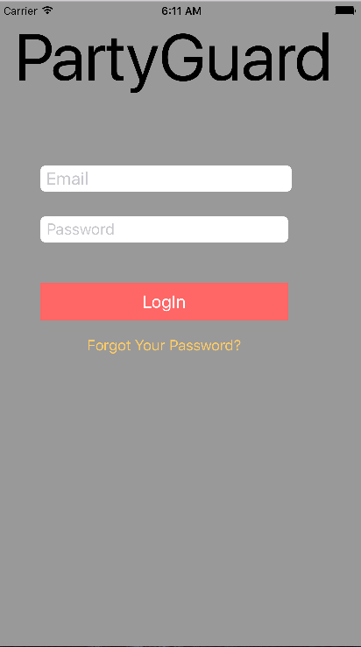

1. **PG Team tab**

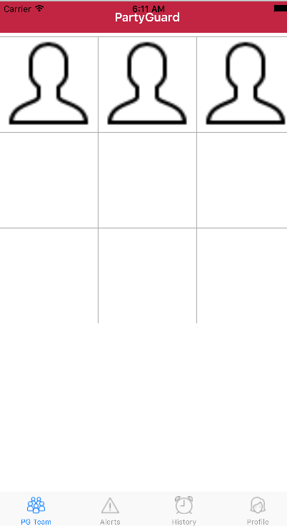

1. **Alerts tab**

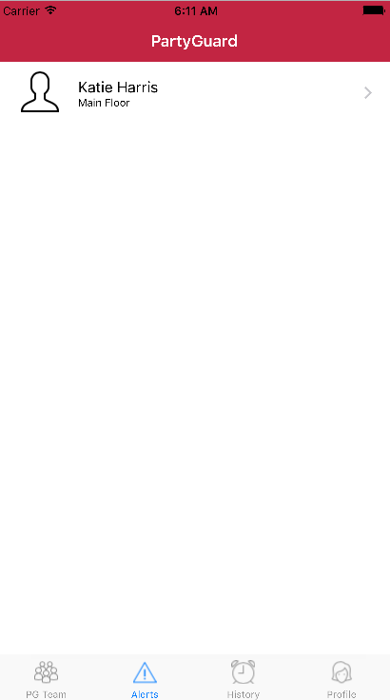

1. **History tab**

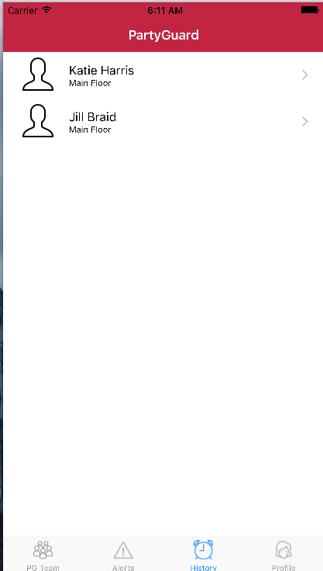

1. **Profile tab**

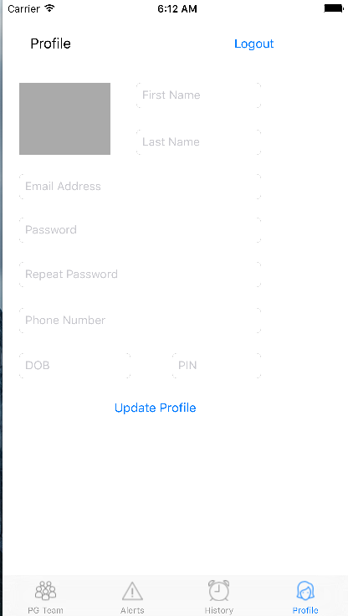

1. **Forgot Password**

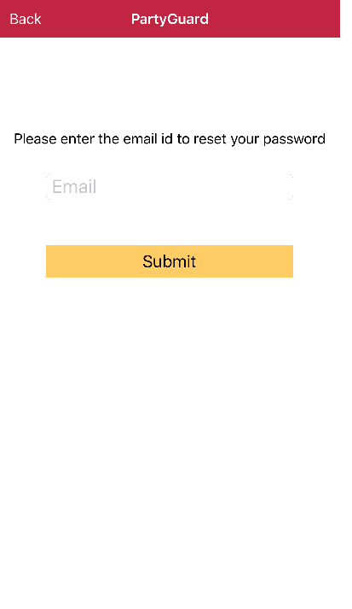

**Link for Repository:** [https://bitbucket.org/bashguardians/bashguardians (Links to an external site.) (Links to an external site.)](https://bitbucket.org/bashguardians/bashguardians)

**Person responsible:**

Vinod, Nandeesh, Yashwanth, and Pushpak – Guard user screens (5 hours each and worked for 3 days)

Sanjeev, Naveen, and Spandana – Forgot password and modifications said by client (5 hours each and worked for 3 days)

**Work in progress:**

* Working on functionality of App information page in basic user
* Working on Location change option in menu of the home page for a basic user

**Link for Trello Board:**[**https://trello.com/b/p8DPSe0J/partyguard-ios-bash-guardians (Links to an external site.) (Links to an external site.)**](https://trello.com/b/p8DPSe0J/partyguard-ios-bash-guardians)